
  H.L. HUNLEY AWARDS & SCHOLARSHIPS
  *** NOW AVAILABLE ***
   | THE GEORGIA DIVISION  SONS OF CONFEDERATE VETERANS  __________________________________________________  "GENERAL CORRESPONDENCE" | 
  Issued by: GEORGIA DIVISION COMMANDER - Timothy F. Pilgrim
  February 27, 2019
  H.L. Hunley Awards & Scholarships now Available
  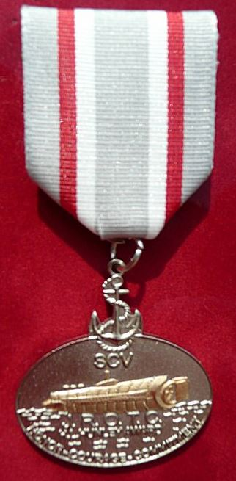 | 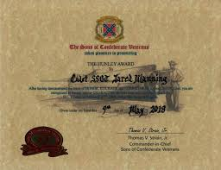  Below is Scott Seay presenting Hunley Award  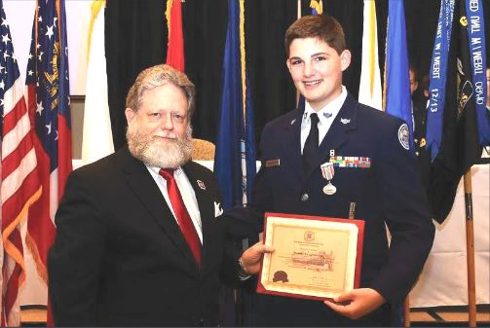
  HL Hunley Awards (Certificates with Medals) are available at our Division Office ready for distribution to the Camps of the Georgia Division for deserving JROTC Cadets.
  For a Camp Commander and/or Camp representative to order a HL Hunley Award from the Georgia Division Office the following information is required at ordering.
  REQUIRED INFORMATION:
  - The Camp number and Commander ordering the award and the mailing address where to ship.
  - Name and address of school.
  - Name and rank of the school contact and their contact information at the JROTC.
  - Name and rank of Cadet.
  - Date of Award presentation.
  - Payment of $30.00 per award.
  To place an order contact mail your $30 check made payable to the Georgia Division to:
  Georgia Division, SCV
  P.O. Box 1081
  Macon, Ga. 31202
  The above required information must be included with your payment or the order cannot be placed.
  If you have any questions please contact Division's HL Hunley Award Liaison Scott E. Seay.
  678-478-6826 Cell
  garebel61@bellsouth.net
  Below is a sample e-mail you can send the JROTC Commander:
  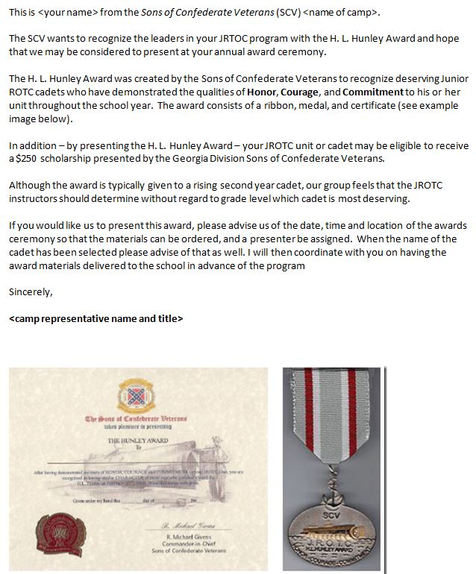
  CLICK HERE FOR A WORD DOCUMENT OF THE SAMPLE EMAIL
  BELOW IS AN APPLICATION THAT THE JROTC COMMANDER CAN COMPLETE.
  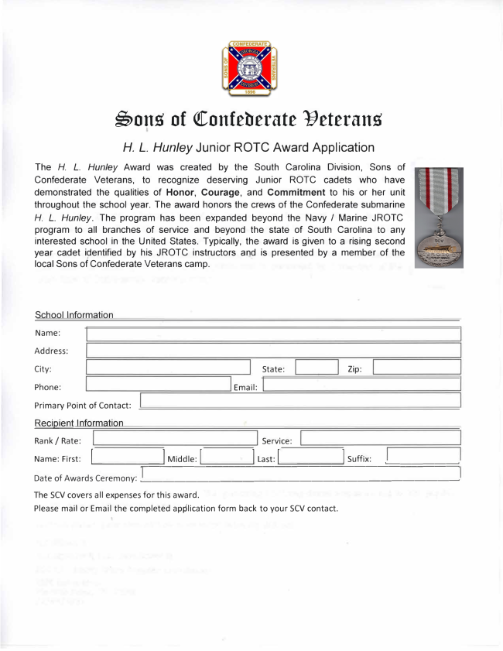
  CLICK HERE FOR A COPY OF THE AWARD APPLICATION
  About the Scholarships:
  - The Division has (26) $250 scholarships available. (2) $250 scholarships per Brigade. We have 13 Brigades.
  - The Brigade Commander makes the decision which (2) Camp will receive the $250 scholarship.
  - The Camp Commander that receives the $250 scholarship will decide if the scholarship goes to the JROTC program, to the recipient for the Hunley award or a graduating senior in the JROTC program. Camp Commander may consult with the JROTC commander on these options.
  - Any Brigade not using their any of their allocated scholarships must make Division Hunley Award Liaison Scott Seay aware by April 14, to make those scholarships available for other schools wasn't able to receive a scholarship.
  - Hunley Liaison Pins are available, please contact on how to receive one:
  Scott E. Seay.
  678-478-6826 Cell
  garebel61@bellsouth.net
  Georgia Division SCV
  H. L. Hunley Scholarship Award Summary
  - SCV Camp Commanders should contact their local high school JROTC units (January - March) and offer the H.L. Hunley JROTC Award (medal & certificate) and notify the school about the possibility of the unit or cadet winning a $250 scholarship.
  - Camp Commanders or camp representatives order the H.L Hunley Award (medal & certificate) from the GA Division Office.
  - Camp Commanders submit their completed Hunley award applications - received from the high school JROTC - to the Brigade commander by March 30.
  - Brigade Commanders will review all Hunley award applications with their Camp Commanders and decide which two (2) applications within the brigade will be awarded the $250 scholarship. Brigade Commanders will notify GA Division HL Hunley Awards Liaison/Scott Seay of the scholarship award recipients.
  - Camp Commanders will contact the JROTC unit commander if that school has won the $250 scholarship and decide whether:
    - the JROTC unit will receive the $250 scholarship
    - the cadet winning the H. L. Hunley JROTC award (medal & certificate) will also win the scholarship
    - a Senior cadet in the unit will win the scholarship
    - GA Division Hunley Liaison/Scott Seay works with GA Division Adjutant/Richard Straut to write the scholarship check and mail to the Camp Commanders.
    - A representative from the camp will attend the JROTC award ceremony to present the H. L. Hunley Award (medal & certificate) and the scholarship.
  Click Here for the detail instructions
  Timothy F. Pilgrim  Georgia Division Commander  timfpilgrim@yahoo.com  404.456.3393 | 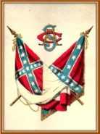
   | To you, Sons of Confederate Veterans, we will commit the vindication of the Cause for which we fought. To your strength will be given the defense of the Confederate soldier's good name, the guardianship of his history, the emulation of his virtues, the perpetuation of those principles which he loved and which you love also, and those ideals which made him glorious and which you also cherish. Remember, it is your duty to see that the true history of the South is presented to future generations. | 
  VISIT OUR WEBSITE

